
Learn How to Draw Amazing Scientific Drawings!

Introduction:
Scientific drawings enable you to look at structures and details that might have gone unnoticed. Drawings are especially useful in helping you to understand macro and microscopic features of plants and animals.

Safety Aspects:
The only thing to keep in mind is that when doing scientific drawings your pencil may be very sharp.

Curriculum Objectives:
S2-0-5c Record, organize, and display data using an appropriate format. Include: labelled diagrams, graphs, multimedia.

Part A: Let’s start with a simple scientific drawing of a macroscopic object, for example, a leaf.

- Start with a plain, unlined sheet of paper and a sharp pencil (preferably an F, H, or 2H pencil).

Why do you want to use a sharp pencil and unlined paper?

____________________________________________________________________

____________________________________________________________________

- Scientific drawings are line drawings. This means that they are made up of smooth continuous lines, there should be no shading. Be sure to draw your picture in the middle of the paper. Draw it so that if fills most of the page, however leave enough room on the right hand side for labelling.

- Label your drawing. All labels should be in printing on the right hand side of the paper. Avoid crossing label lines at all costs. Use a ruler to make lines straight.

Why is it important not to cross the label lines? ___________________________

_________________________________________________________________

- Draw a scale bar in the bottom right hand corner of the drawing.

Ex. Say the width of the actual leaf is 5cm and your drawing is 8cm wide. (It is larger than life).

You can calculate how many times larger your drawing is by doing the following, 5cm:1 :: 8cm:x solve for x and it gives you 1.6. Thus draw a line that is 1.6 cm long on your paper. This line represents 1 cm of your plant.

- Put a title underneath the drawing of the plant leaf. The title should include; figure number, name of the plant (common and scientific), the view, magnification and a small description. Italicize or underline the scientific name of the plant.
Ex. Fig. 1 External morphology of a Fagus grandifolia, beech tree leaf at 1.6 times magnification.

Why do you want to include a scale bar and title in your drawing? _________________

_______________________________________________________________________

Part B: Let’s now move onto microscope drawings. Recall the lab on compound and dissection microscopes.

1. The first thing is to determine the field diameter at the 4x, 10x, and, 40x objectives. Do this by inserting a micrometer slide into your microscope. Focus and measure the field diameter.

Ex. 4x was 4700 m, 10x was 1850 m, and 40x was 450 m.

Thus if the reading of a 40x objective is 450 m, the field diameter is 0.450 mm.

2. Put your specimen slide under the microscope. To find the actual size of any specimen, estimate how much of the field diameter it occupies. Multiply this by the known field diameter.

Ex. A spore specimen occupies 1/8 of the field diameter at a 40x objective. Thus its actual size is how big? Give an answer in mm, show your work in the space provided below.

3. Finish drawing the object or specimen following the same procedure as outlined in steps 1 to 5 of the macroscopic drawings.

Remember the rules for good scientific drawings:

1. Use a sharp F, H or 2H pencil for both drawings and labels.
2. Use unlined paper only.
3. Draw clearly defined structures with smooth, continuous lines.
4. Maintain accurate proportions.
5. Make drawings large enough so you can easily show the smallest details.

6. Leave enough room for labels.
7. Labels neatly, ie. Print.
8. Give a title. Write the title below the drawing.
- name of specimen

- view
- magnification
- scale line

Part C: Now that you have a good understanding of how to make scientific drawings, use the paper provided at the back do the following two drawings:

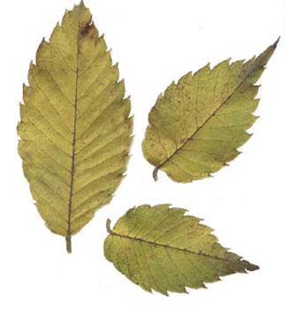
1. A macroscopic or life size drawing of a Fagus grandifolia (beech tree leaf).

An image of the leaf is shown to the right. Be sure to use the live specimen when making your scientific drawings.

Using your class notes make sure to
identify the blade or lamina and petiole.

2. A microscopic image of a leaf cross section. Make your drawing from the prepared slides. A picture of the slide is shown below.

Using your class notes, be sure to include the following features; epidermis, cuticle, stomata, guard cells, trichomes, parenchyma, collenchyma, sclerenchyma, and chloroplasts.
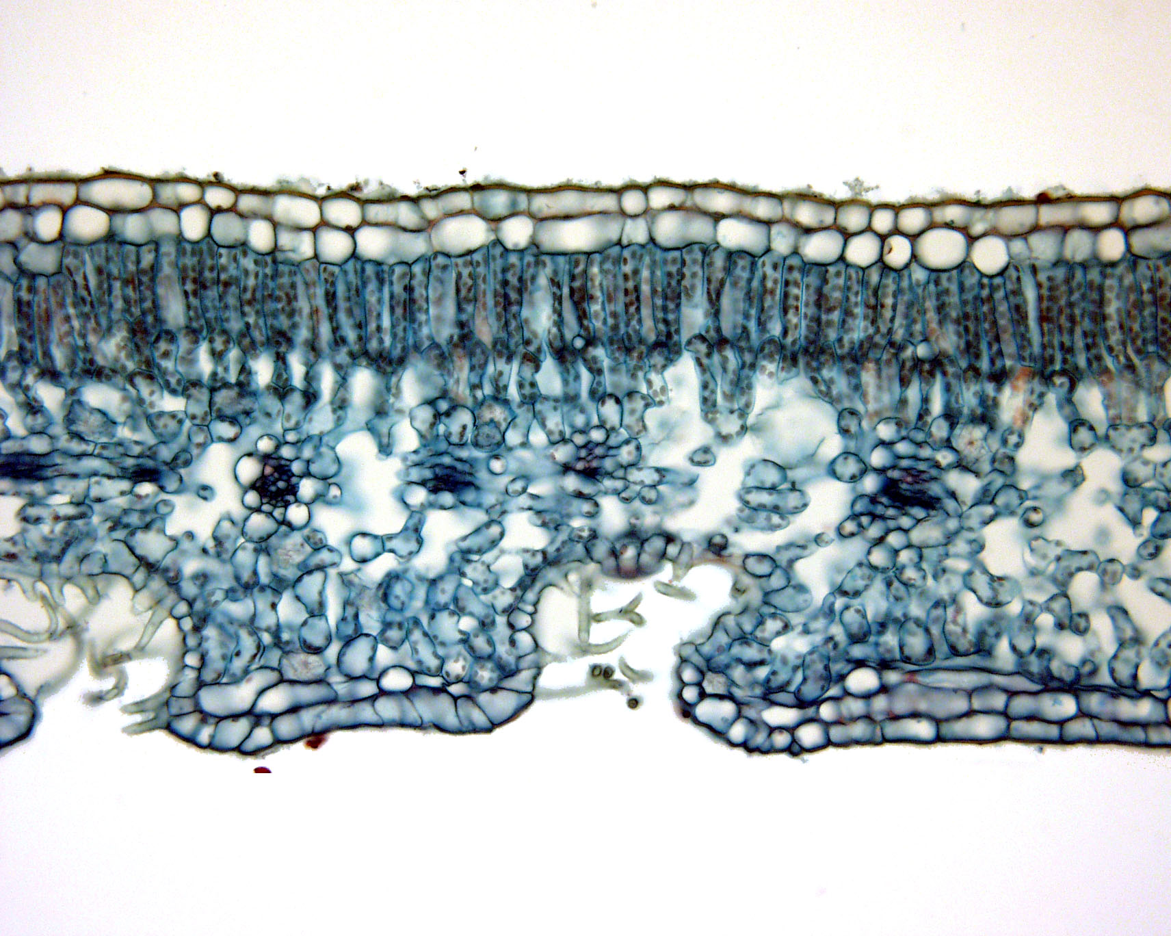

Answer the following questions:

Why is it important to know how to make scientific drawings?

_______________________________________________________________________

_______________________________________________________________________

Name two or three situations where we might find/use scientific drawings.

_______________________________________________________________________

_______________________________________________________________________

What are the short comings of scientific drawings? Does it represent reality?

_______________________________________________________________________

_______________________________________________________________________

What have you learned by doing this activity? _________________________________

_______________________________________________________________________

References

1. Ford, Bruce, 2005, 1.211 Mosses, Ferns and Conifers Laboratory Hand-out, Botany department, University of Manitoba.

2. Waters, Isobel, Sept 2005. 1.202 Plant Structure and Function 1 Laboratory Manual, Botany department, University of Manitoba.

